Bedroom night time dimming of LEDs

Create a dim time and bright time in the scheduler

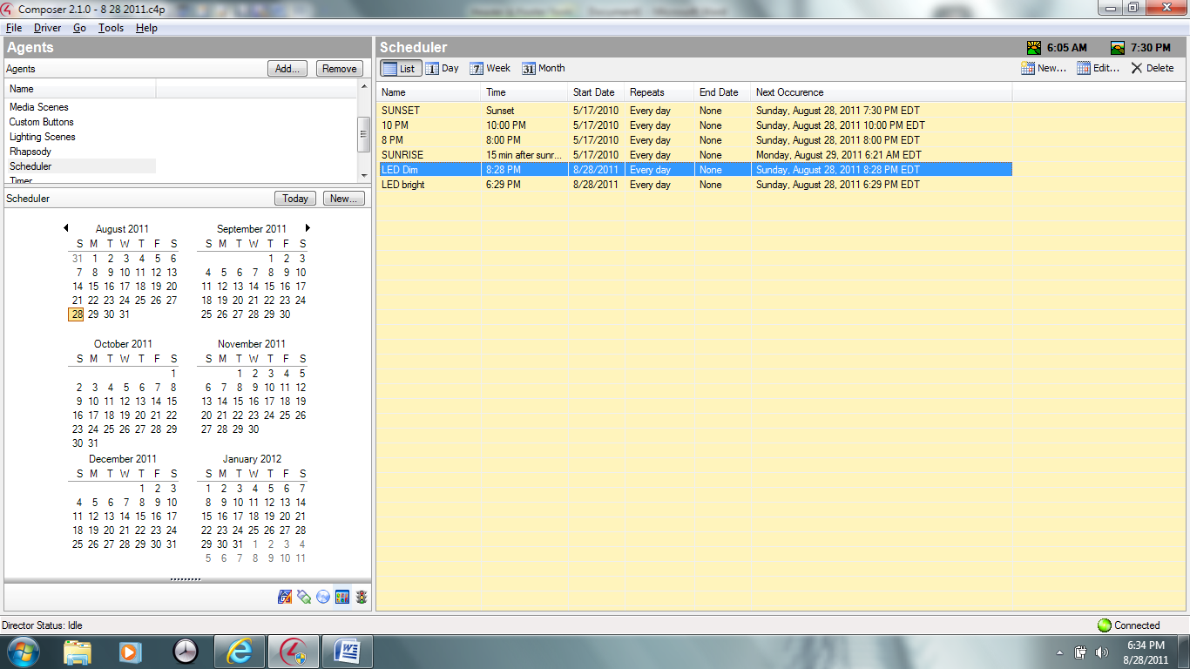

When the schedule event happens change the LED colors. Go to black for off at night or create custom color. When the schedule in the morning happens change LED back to standard color.

