How to make a dimmer a key-pad or how to create scene dimming.

In this example we have a dimmer labeled "S-3 Eating area" there is no load connected to the dimmer. We have a dimmer labeled "Eating area pendant" this has the load.

We create a room with all the dimmer "key-pads" with no loads and we hide them in the navigator. We label them as "S-3" xxx.

Set the preset level to be the same for the load and key-pad. In system designer.

In programming expand the "S-3" select light level.

In Actions expand the "S-3" select light level, select conditionals and select is the "S-3" light level greater than (in the pull down select the loads light level) load light level.

Repeat for less than.

In Actions select the load, expand select light level.

In commands select set to value of (in the pull down select the "S-3" light level)

For Scene dimming this is where you would add all the loads you want in the scene

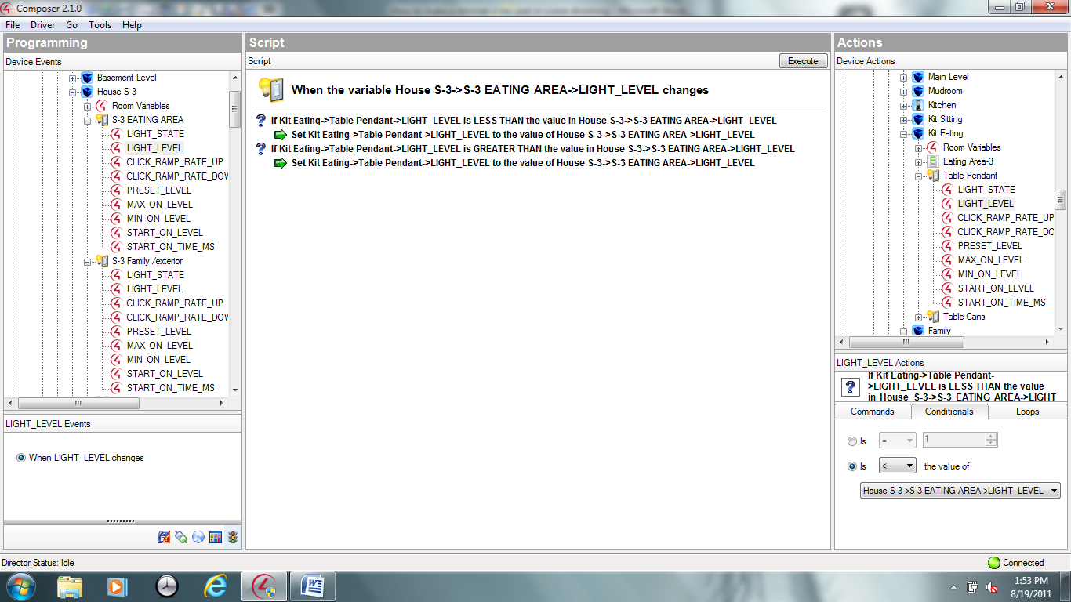

Please note the variable is how I monitor for an area on/off (not related to this function)

On the Load expand and select light state. Conditionals if the load is on turn on the "S-3" if its off turn off the "S-3" this will insure proper led tracking.

