Motion control with touch screens

This programming will allow a switch that controls a lighting zone which is motion controlled to turn the light on and prevents the motion control timer from shutting the light off. The program adjust for touch screen control. If you turn the light on from the touch screen and set a sensor "off" the lights will turn off with the sensor timer. If you turn the light off after turning it on with the switch the sweep timer will reset the over ride.

The program uses a resetting timer so if you keep setting off the sensors the timer never expires and the lights stay on

Start by creating your timers

Create 1 timer to reset all over rides and 1 timer for each lighting zone you want motion controlled

System timer "variable sweep" make sure you check repeating

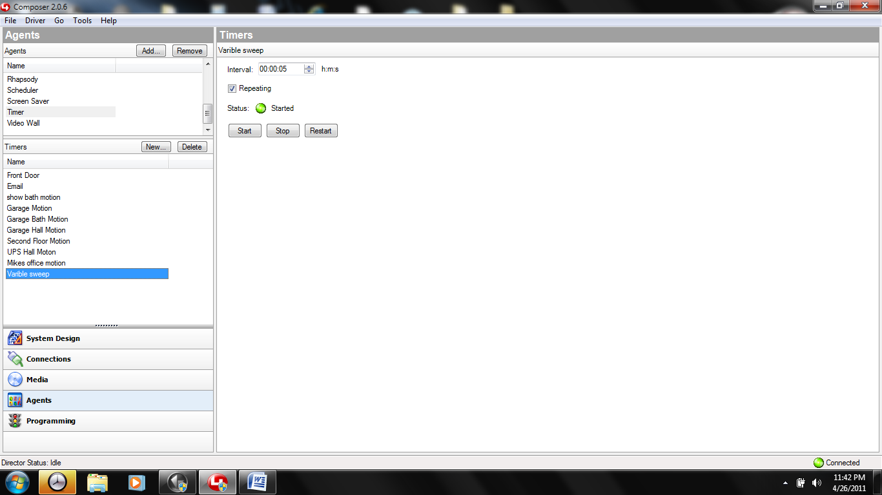

Timer for light on delay "garage motion timer" I use 5 second intervals you can use any variation just make sure to check repeating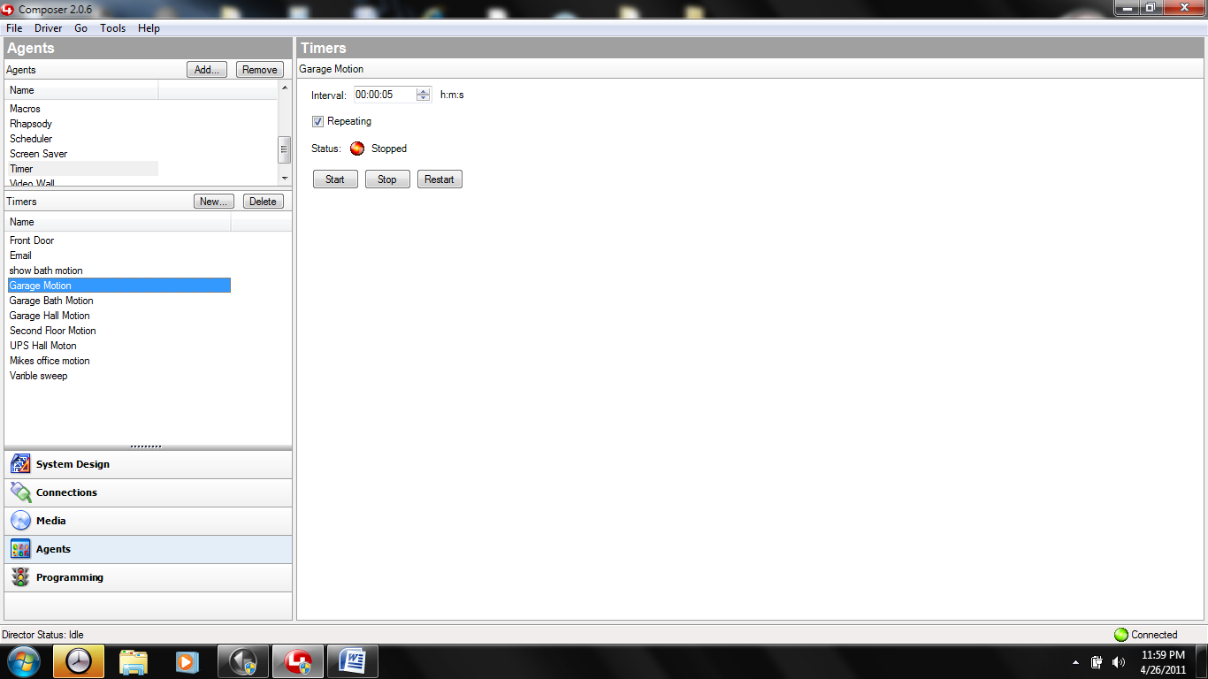

Programming for "sweep timer"

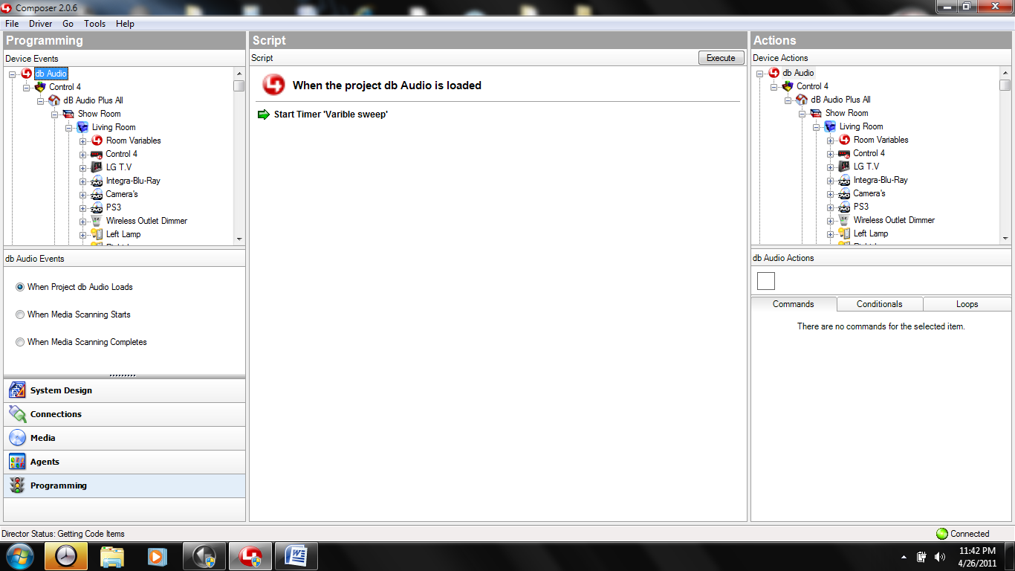

Programming for "garage motion timer" subtract -1 from "garage motion" every time it expires

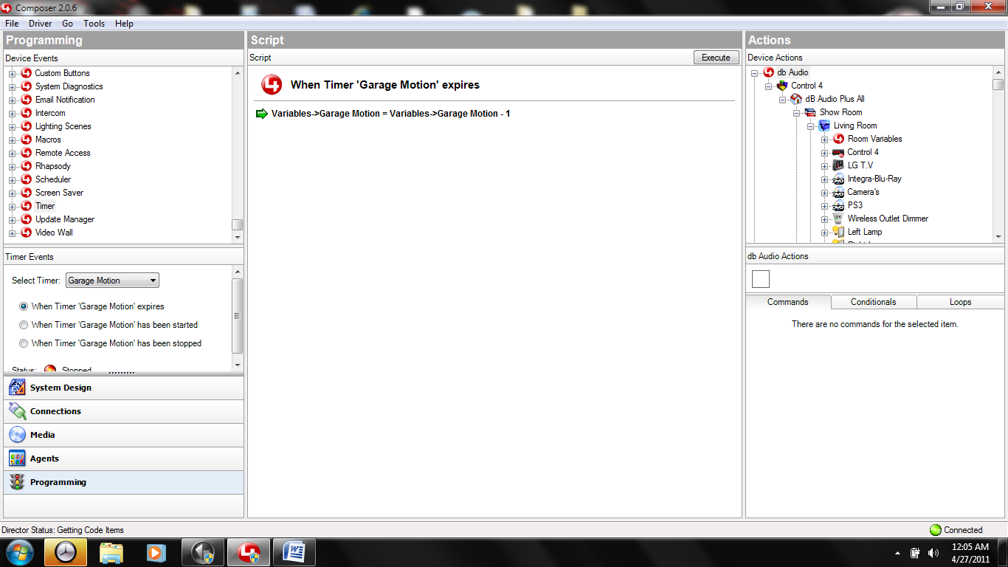

Programming on the system timer "variable sweep" (resets all over rides every 5 seconds if they are wrong) need a statement for every light motion controlled.

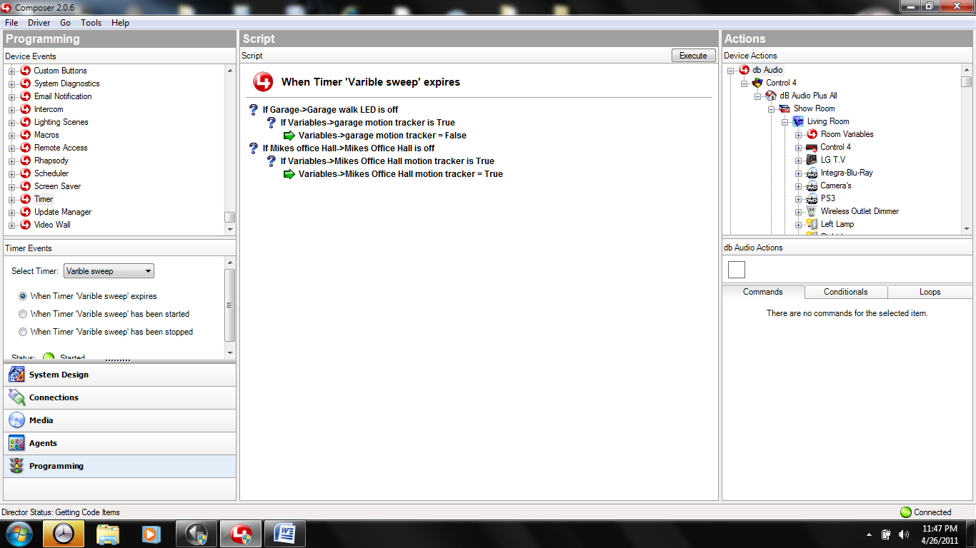

Make 2 variables for each light (light timer, and over ride)

Motion delay variable "garage motion" (time light is on) number type

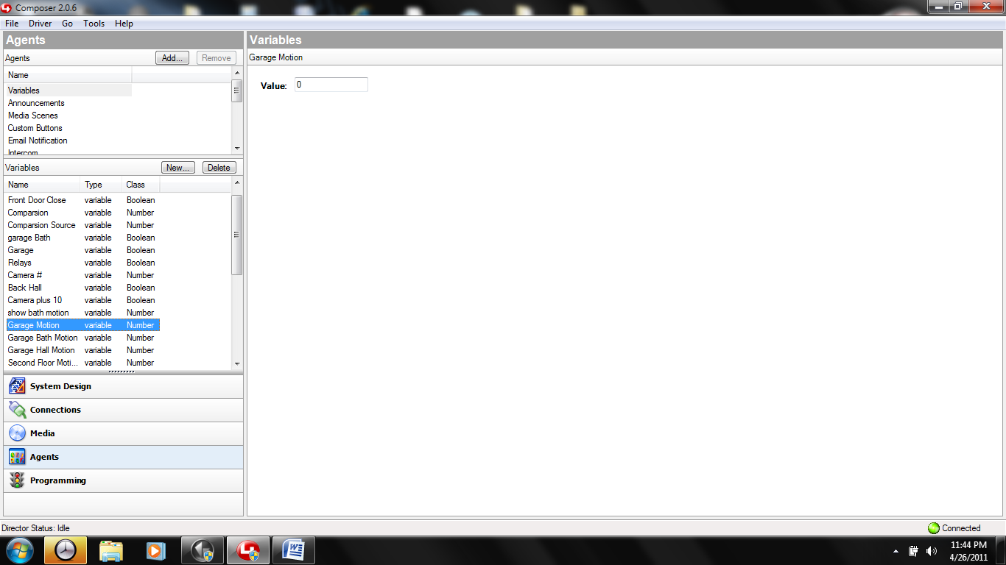

Motion tracker variable (motion over ride) type boolean

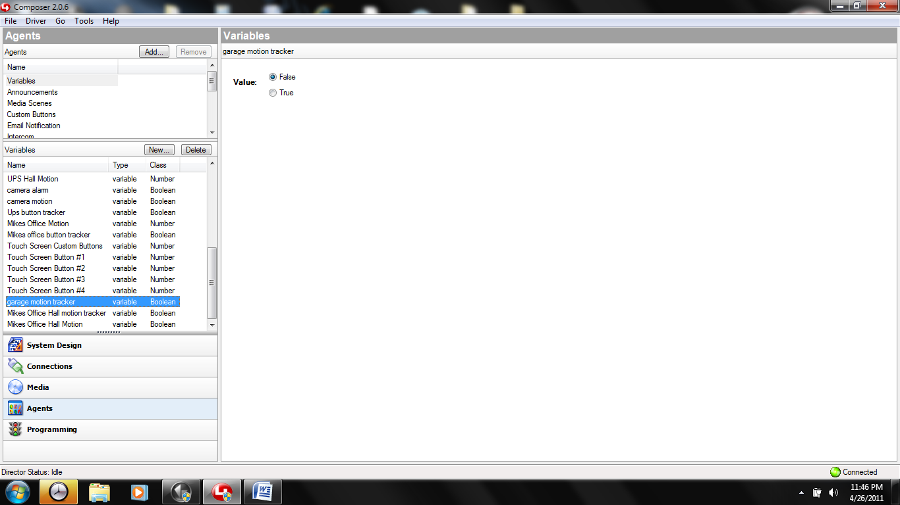

programming on "garage motion" (light on timer) variable

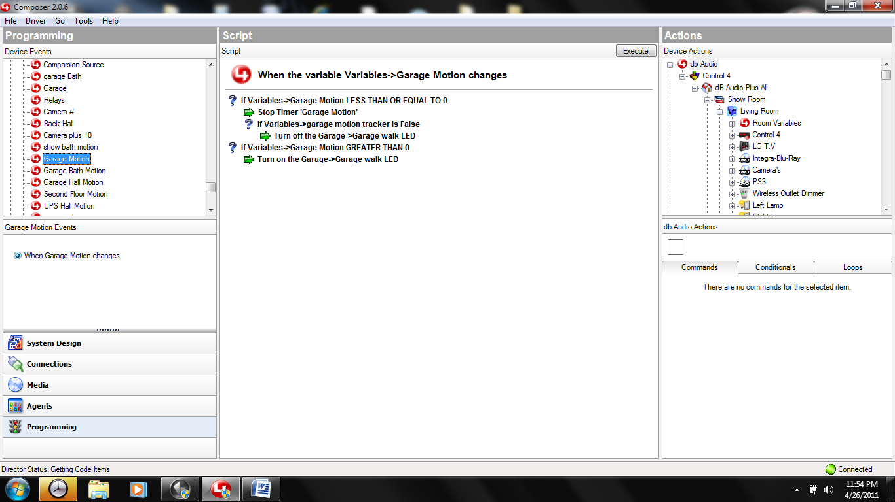

No Programming on "garage motion tracker" (over ride) variable

Programming on each sensor the higher the number the longer the on delay the program uses a resetting timer so if you keep setting off the sensors the timer never expires and the lights stay on

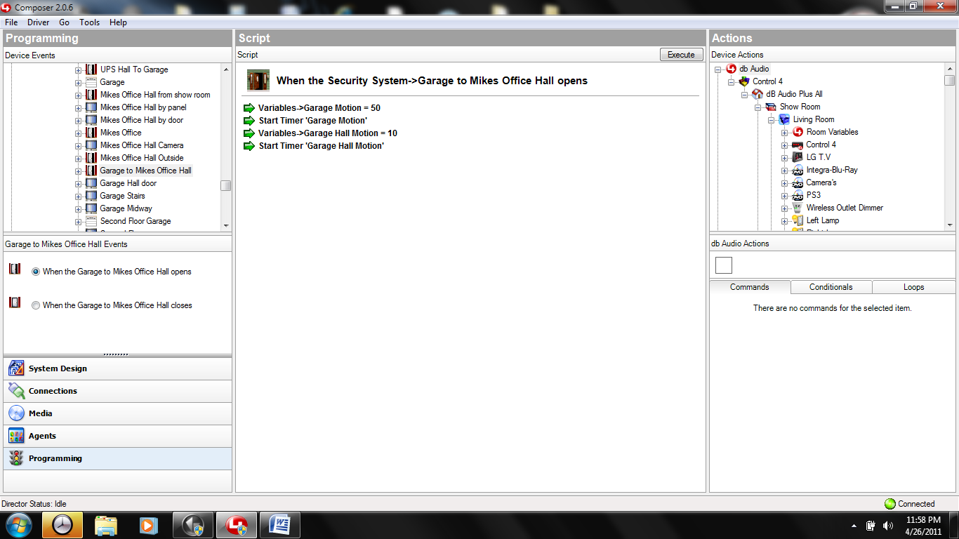

Top button press "on" programming on the switch that controls the lighting zone motion controlled will turn the light on and prevents the motion control timer from shutting the light off.

If you turn the light on from the touch screen and set a sensor "off" the lights will turn off with the sensor timer. If you turn the light off after turning it on with the switch the sweep timer will reset the over ride.

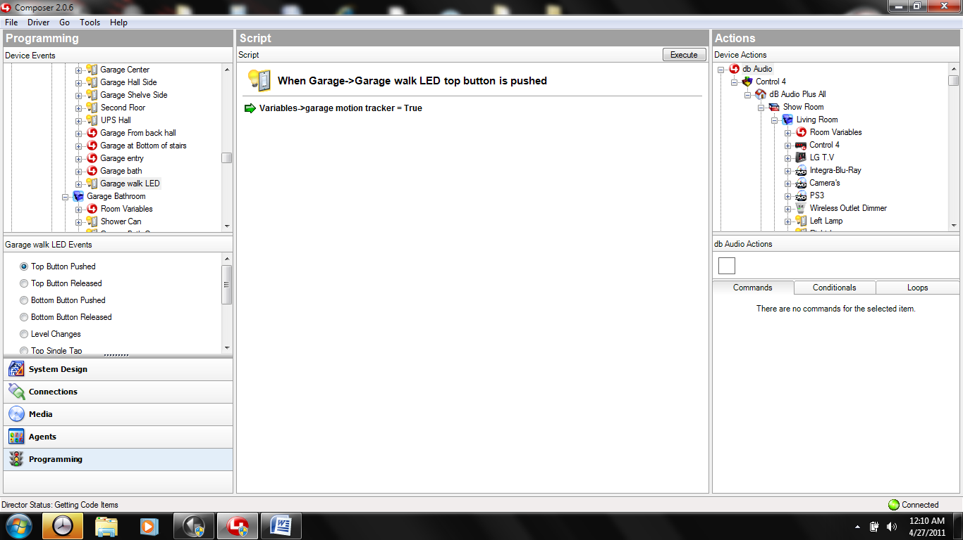

Bottom switch press "off" turns light off and resets over ride and prevents the motion timer from turning the lights back on

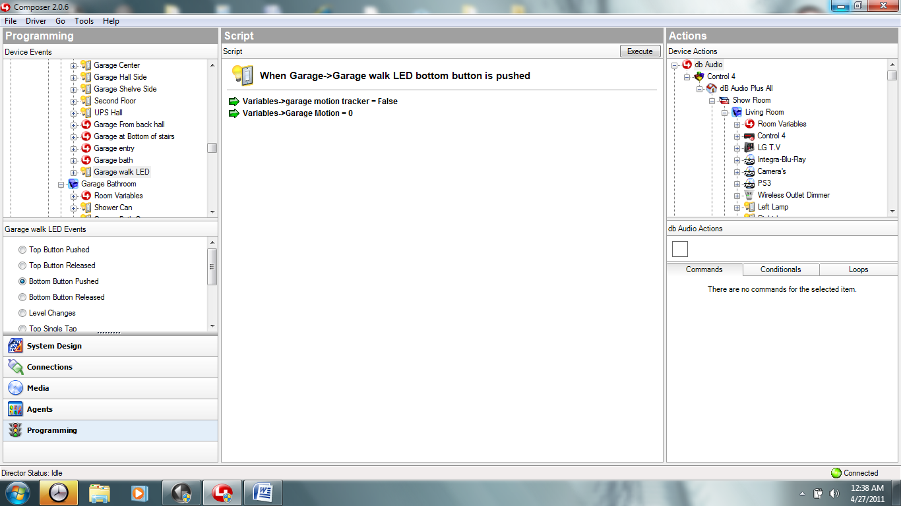

Programming for third party switches (vantage) single button / toggle function

In system tab add vantage keypad then

From vantage you need to obtain switch vid# and button vid# make sure to "set" your entry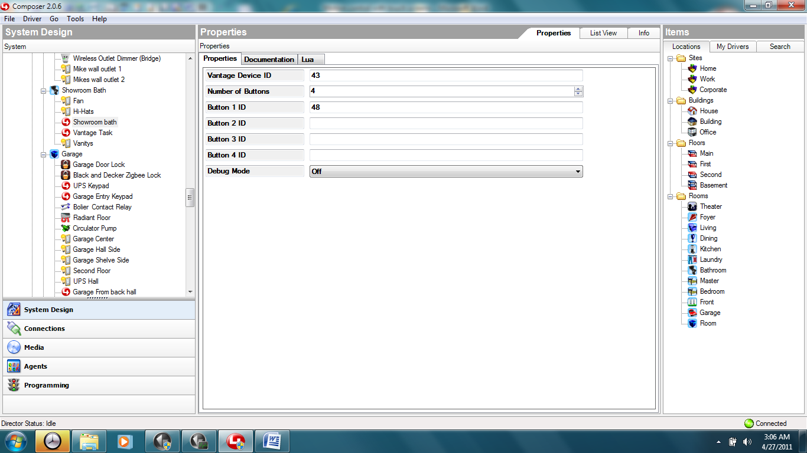

For programming select the correct button press

