Scene control and diming from a single key pad button

Start with a key pad button and un-bind the key pad buttons and create on and off colors.

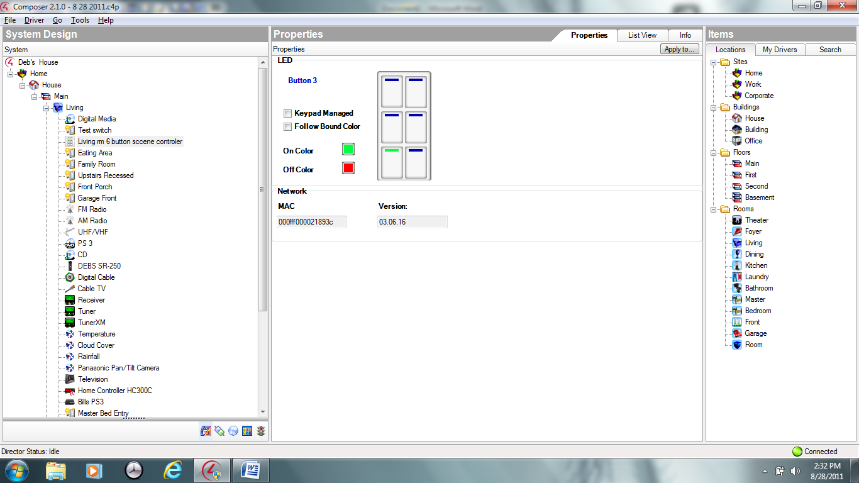

Create a variable for each button (type is boolean)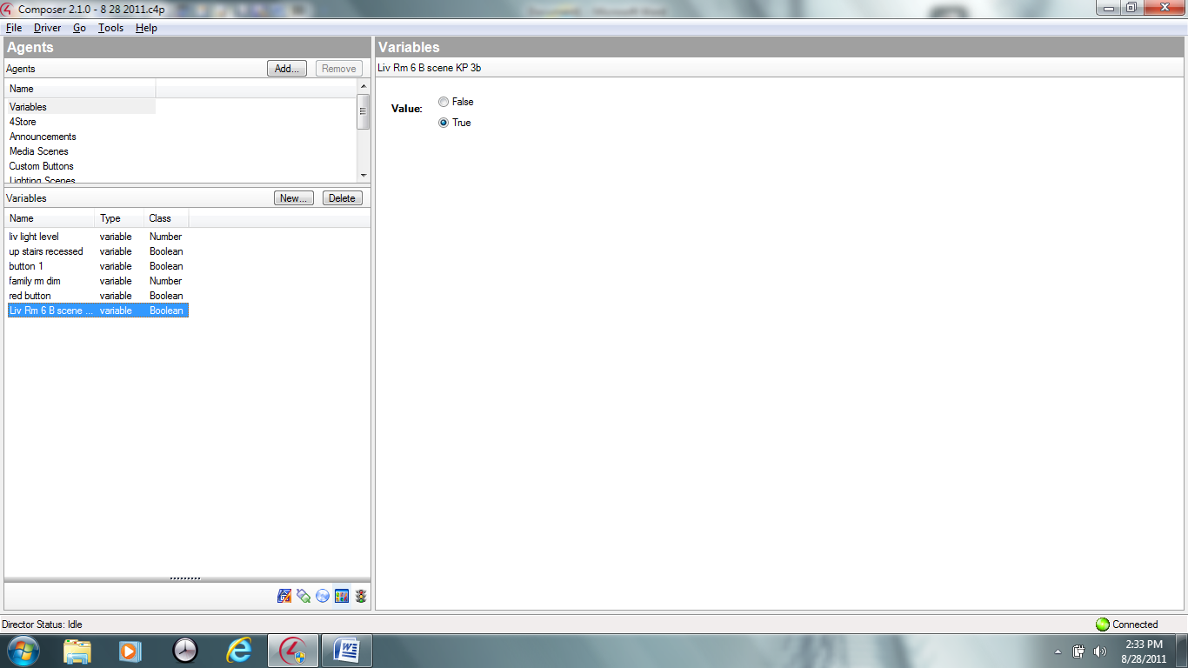

Create a timer make repeating use 1 second interval, (you need a timer for each button)

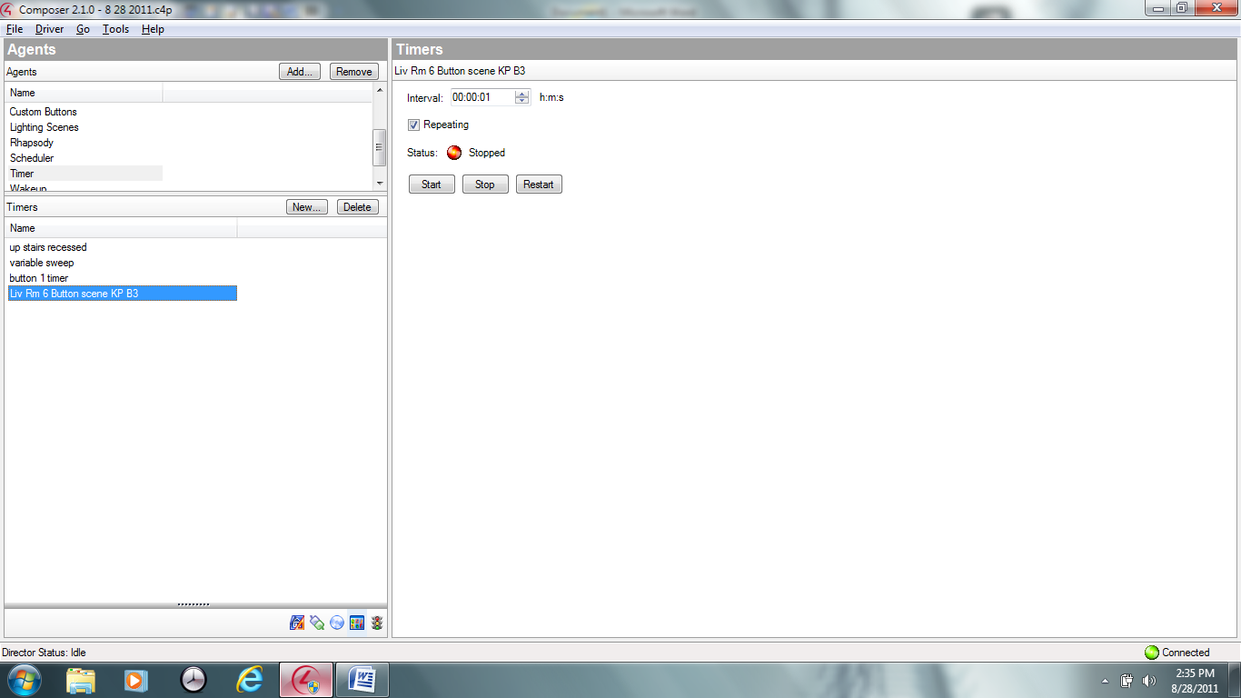

Programming on Button #3

"On press", "On release", "On Single tap" optional programming on "On double tap" if you have the preset set to less than 100 %

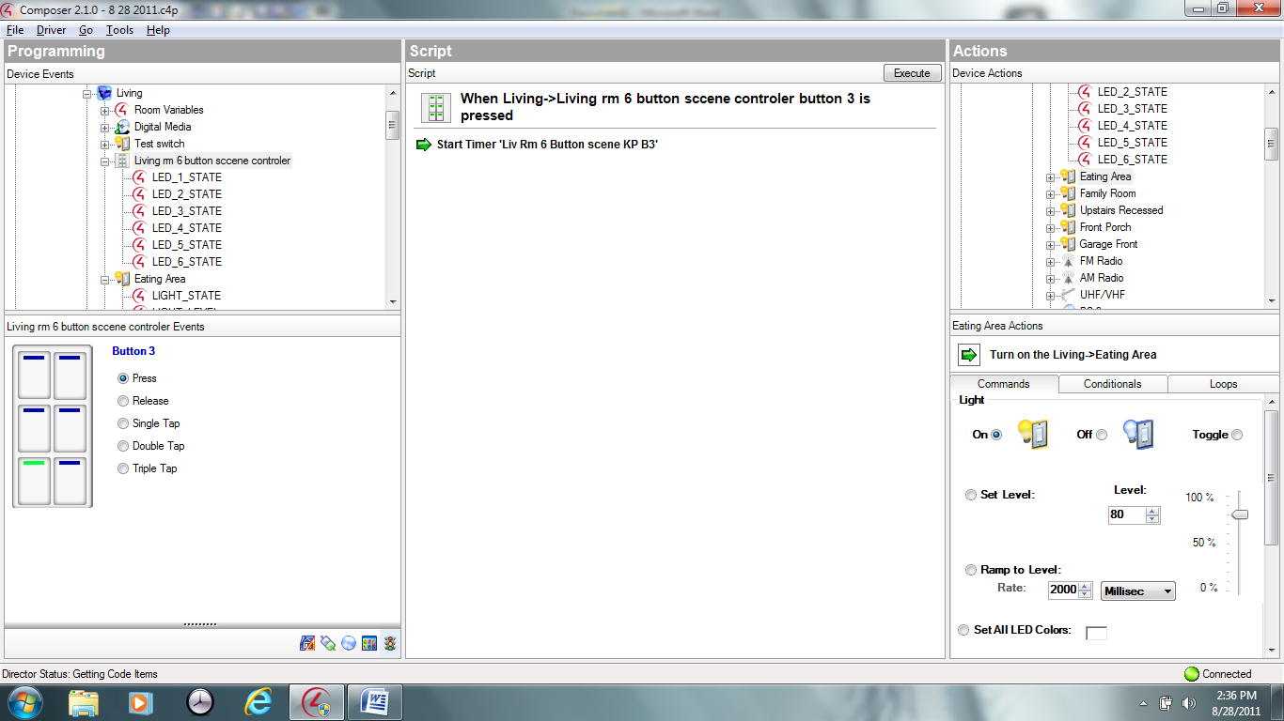

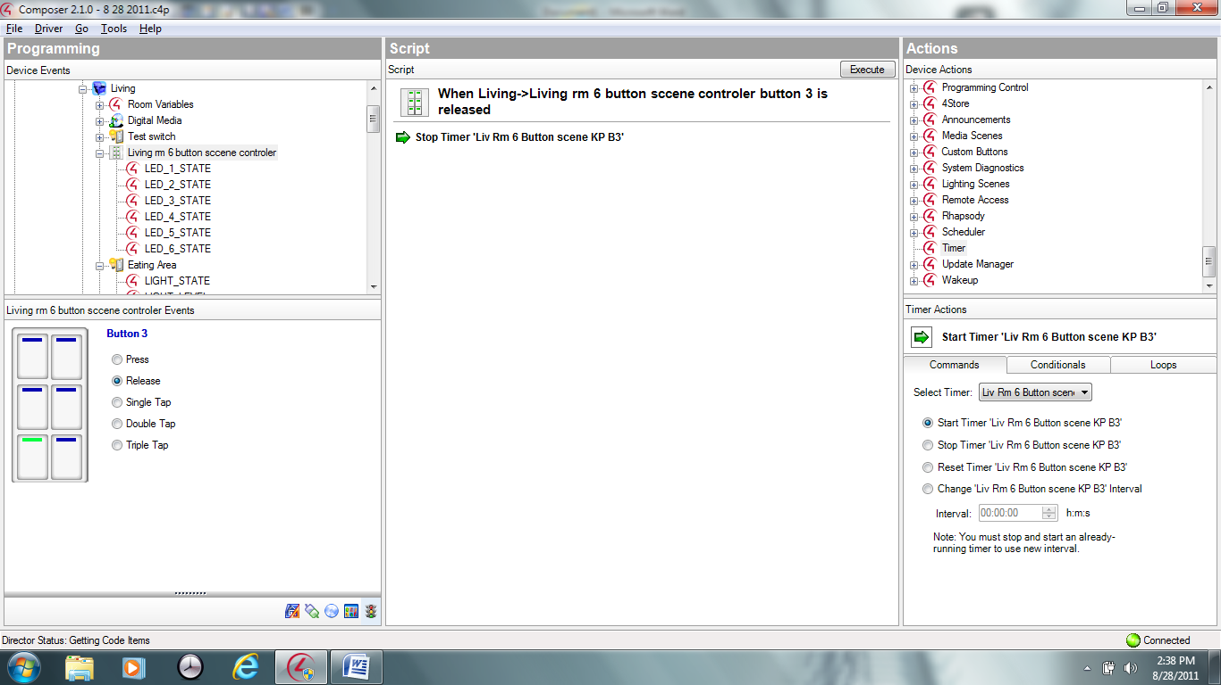

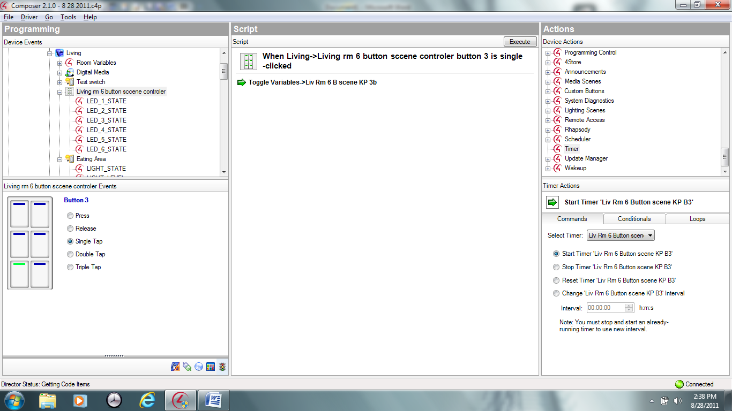

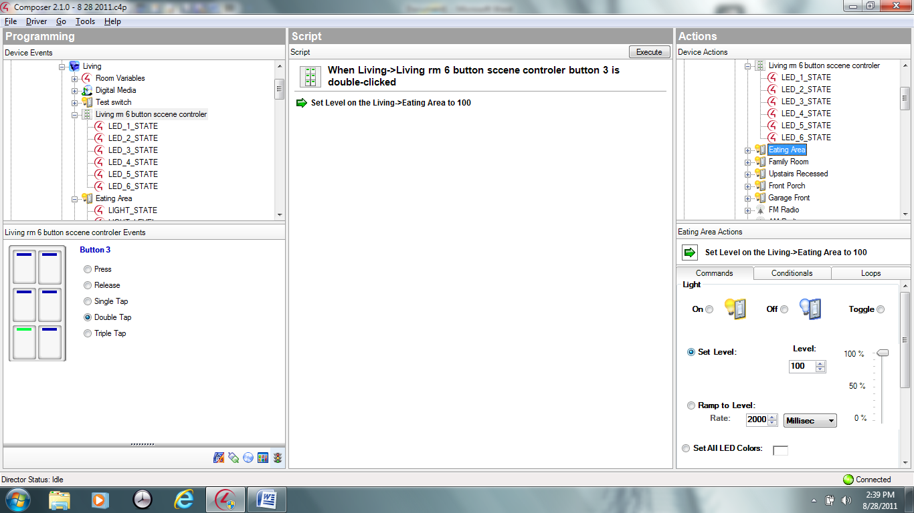

You need to expand the load and select light state and place programming in it Programming for a single load